OOREDOO MALDIVES
Minutes for Apr’24 Review (May 22nd, 2024)

Attendees:
OG: Najib Khan, Alok Verma, Htar That Zin, Sean Borejszo, Vipul Sharma, Helene Le Caignec. OG Online: Abdulla Ahmed Al Zaman, Anandi Agnihotri, Anton Landman, Zin Mar Aung, Hassan Khatoun Neama, Prakash Kumta Mohandas, Shehryar Malik, Baha Soliman, Vivek Gupta
OMV: Khalid Al Hamadi (MD & CEO); Suresh Kalpathi Chidambaram (CFO); Hussain Niyaz (CCO); Rajesh Mehta (CBO); M.S. Tanwar (CTIO); Fazna Mansoor (Dir. HR & Admin); Tushar Dirwani (Dir. Strategy & PMO); Hussain Zareer (Dir. Finance); Ismail Shaheem (FC); Hussain Niyaz (Mgr. Management Accounting); Ahmed Sumeen (Act. Sr. Executive ERM); Ahmed Fariz Khaleel (Asst. Mgr. BI & DA); Vinay Mangal (Head of Products); Mohamed Ibrahim (Head of Network Build); Shabeen Ali (Dir. Operations); Naafiz Abdulla (Sr. Mgr. Digital Services); Mohamed Aksham (Sr. Mgr. Distribution),

Apologies: Ahmad Al Neama, Bilal Kazmi, Saim Yaksan, Timos Tsokanis, Fatima Al Kuwari, Hilal Al Khulaifi, Sh. Nasser Al Thani, Rene Werner, Eyas Assaf, Dhiyana Afeef (Head of Customer Care); Fathimath Saba (Head of Finance),

 | Minutes | Action
1. | Opening Message:  CEO Khaled Al Hamadi gave a brief summary of OMV strong perforrmance with YoY growth.  Gross Revenue is higher by +3.3% vs budget and MoM is lower by -1.9%  - Mobile business is higher by +4.4% vs budget and +0.8% higher vs Mar’24  - Fixed Broadband is higher by +1.4% vs budget and flat vs Mar’24  - Supernet is lower by -0.2% vs budget and +0.3% higher vs Mar’24  - Wireless is higher by +7.3% vs budget and -1.0% lower vs Mar’24  - Fixed Enterprise (ILL & Solutions) is higher by +3.2% vs budget and +13.4% higher vs Mar’24  - Wholesale business is higher by +1.7% vs budget and -16.3% lower vs Mar’24  - Digital – MAU at 222K in Apr’24 vs 220K in Mar’24, it is +0.8% higher  OMV CFO/Kalpathi provided some update on Mobily 2.8Mn USD Bad Debt  - In Nov/Dec’23 some traffic passed through after the end of the partnership agreement through highest rating channel (14) following relevant communication between OMV and Mobily.  - Traffic ws blocked in Dec’23 after realization of 2.8Mn USD invoice to be paid  - OGBS has communicated with Etisalat Group on issue. Etisalat Group advising Mobily to pay due amount.  - Still WIP
2. | Q&A  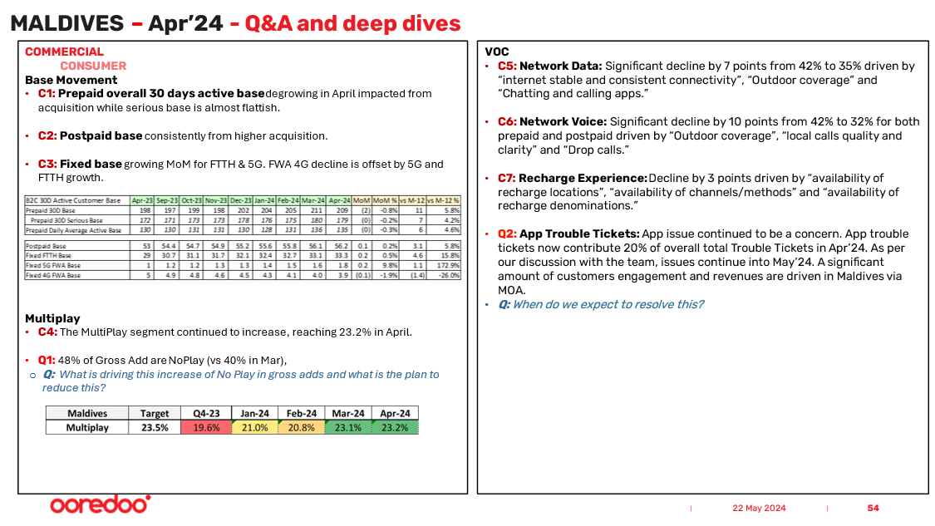  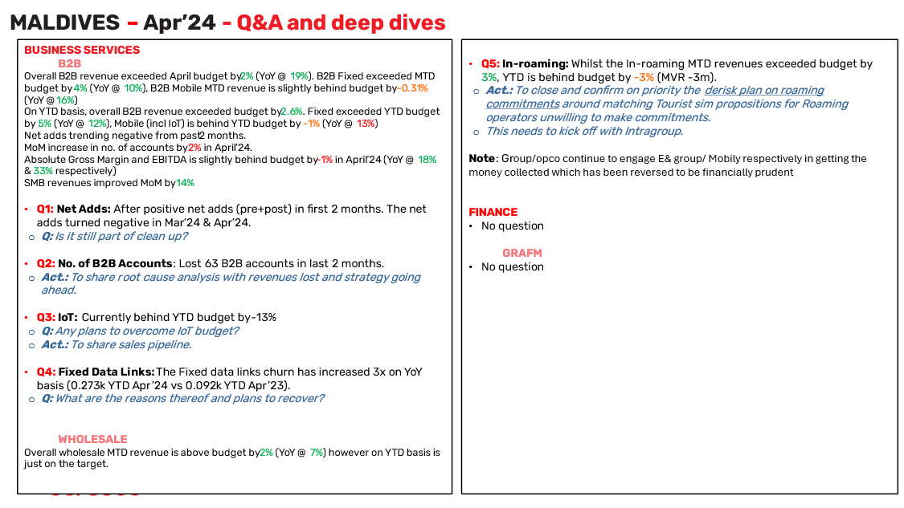  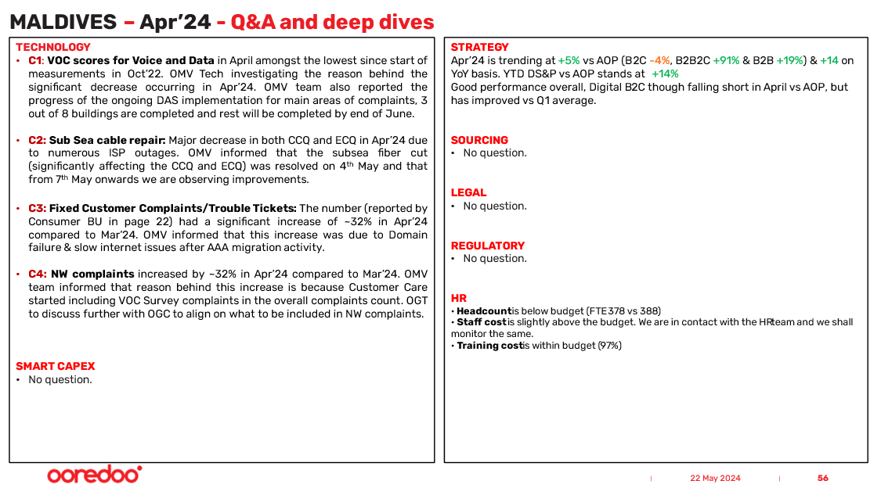  COMMERCIAL  CONSUMER  Base Movement  - C1: Prepaid overall 30 days active base degrowing in April impacted from acquisition while serious base is almost flattish.  - C2: Postpaid base consistently from higher acquisition.  - C3: Fixed base growing MoM for FTTH & 5G. FWA 4G decline is offset by 5G and FTTH growth.  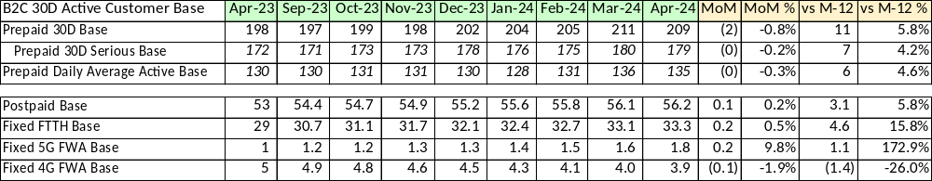  Multiplay  - C4: The MultiPlay segment continued to increase, reaching 23.2% in April.  - Q1: 48% of Gross Add are NoPlay (vs 40% in Mar),  - Q: What is driving this increase of No Play in gross adds and what is the plan to reduce this?  OMV: A significant part of the decline is due to seasonality. We are implementing quality measures at the reseller level and introducing segmented offers to address this issue.  Quality of GA should improve in a couple of months.  VOC  - C5: Network Data: Significant decline by 7 points from 42% to 35% driven by “internet stable and consistent connectivity”, “Outdoor coverage” and “Chatting and calling apps.”  OMV: Customers who have rated low in key driver “internet stable and consistent connectivity”, are mainly located in Hulhumale’, Male’ resorts and K.Fushi.  Customers who rated low in key driver “Outdoor coverage” were located mainly in Male’, HM phase 2, Kulhudhuhffushi and resorts.  There were no direct comments from low-rated customers to key driver “Chatting and calling apps.” Unrelated to network specifically; customers have highlighted high prices for data add-ons and a desire for more offer variety.  OMV CTIO/Tanwar: proper measures have been taken  OGC/Alok: to watch out and monitor closely. WATCH OUT POINT  - C6: Network Voice: Significant decline by 10 points from 42% to 32% for both prepaid and postpaid driven by “Outdoor coverage”, “local calls quality and clarity” and “Drop calls.”  OMV: “Complete calls without facing any drop” customer rating low for this key driver were mainly located in Greater Male, resorts and islands such as K.Maafushi, Th.Omadhoo, AA.Rasdhoo & AA. Mathiveri. From customer feedback, we have noted mainly non-network related areas of improvement on high prices, bill related, package change queries.  “Outdoor call coverage” - Customers rating low for this criteria are mainly located in Greater male & resorts. Low coverage & slow speed was highlighted by customers.  “Customers rating low for “National call quality” key driver are mainly located in Greater Male & resorts. From customer feedback, low indoor coverage was highlighted related to network. Other feedback include on App related, bill related & high prices.  OMV CTIO/Tanwar: proper measures have been taken  OGC/Alok: to watch out and monitor closely. WATCH OUT POINT  - C7: Recharge Experience: Decline by 3 points driven by “availability of recharge locations”, “availability of channels/methods” and “availability of recharge denominations.”  OMV: In the category of “availability of recharge denominations” low rated customers did not comment directly on denominations but mentioned issues like credit loss and the inconvenience of self-recharging when data or WiFi is inaccessible.  For “availability of channels/methods,” there were no direct feedback from low-rated customers; instead, they highlighted high prices, slow data network speeds, and dissatisfaction with promotions. There is also no significant variance when it comes to CSAT of channels; RAASTAS improved by 2% while website dropped by 1%.  Regarding “availability of recharge locations,” no direct comments on this driver. Unrelated feedback included concerns about pricing and app issues.  - Q2: App Trouble Tickets: App issue continued to be a concern. App trouble tickets now contribute 20% of overall total Trouble Tickets in Apr’24. As per our discussion with the team, issues continue into May’24. A significant amount of customers engagement and revenues are driven in Maldives via MOA.  - Q: When do we expect to resolve this?  OMV: We have seen decline after the App fix on rootby pass after 29th April.  Aging tickets team are working to close this with new security build that is getting close by May.  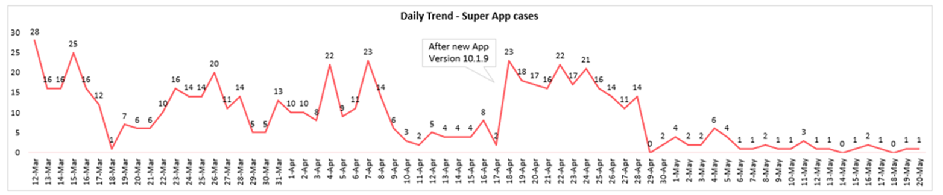  OMV recognizes that this has been a pain point.  OMV CTIO/Tanwar explained that vendor had been a problem for quite some time, however the last days of Apr’24 and first 20 days of May’24 show a rather stable situation and complaints shave gone as shown is chart above. Albeit this, there are still some issues OMV is working on.  If things do not improve OMV might have to change vendor.  OGC/ Alok proposing to provide support from Group and from other OpCos’ experience.  BUSINESS SERVICES  B2B  Overall B2B revenue exceeded April budget by 2% (YoY @ 19%). B2B Fixed exceeded MTD budget by 4% (YoY @ 10%), B2B Mobile MTD revenue is slightly behind budget by -0.31% (YoY @16%)  On YTD basis, overall B2B revenue exceeded budget by 2.6%. Fixed exceeded YTD budget by 5% (YoY @ 12%), Mobile (incl IoT) is behind YTD budget by -1% (YoY @ 13%)  Net adds trending negative from past 2 months.  MoM increase in no. of accounts by 2% in April’24.  Absolute Gross Margin and EBITDA is slightly behind budget by -1% in April’24 (YoY @ 18% & 33% respectively)  SMB revenues improved MoM by 14%  - Q1: Net Adds: After positive net adds (pre+post) in first 2 months. The net adds turned negative in Mar’24 & Apr’24.  - Q: Is it still part of clean up?  OMV: Due to disconnection of election campaign nos. and construction company due to project completion.  - Q2: No. of B2B Accounts: Lost 63 B2B accounts in last 2 months.  - Act.: To share root cause analysis with revenues lost and strategy going ahead.  OMV: This is the cleanup of Supernet accounts and has no revenue impact.  - Q3: IoT: Currently behind YTD budget by-13%  - Q: Any plans to overcome IoT budget?  - Act.: To share sales pipeline.  OMV: IoT revenue growing at 5% minus one government account revenue due to project completion.  - Q4: Fixed Data Links: The Fixed data links churn has increased 3x on YoY basis (0.273k YTD Apr’24 vs 0.092k YTD Apr’23).  - Q: What are the reasons thereof and plans to recover?  OMV: April’24 is higher due to cleanup of Supernet accounts and has no revenue impact.  OMV CBO/Rajesh foresees revenue to cascade from new projects (ICT). There are no major big resort projects now. All projects will be closed in 2025/26.  Recurring revenue is doing well.  Growth is driven from large businesses.  WHOLESALE  Overall wholesale MTD revenue is above budget by 2% (YoY @ 7%) however on YTD basis is just on the target.  - Q5: In-roaming: Whilst the In-roaming MTD revenues exceeded budget by 3%, YTD is behind budget by -3% (MVR -3m).  - Act.: To close and confirm on priority the derisk plan on roaming commitments around matching Tourist sim propositions for Roaming operators unwilling to make commitments.  - This needs to kick off with Intragroup. NEW ACTION  Note: Group/opco continue to engage E& group/ Mobily respectively in getting the money collected which has been reversed to be financially prudent.prudent  FINANCE  - No question  GRAFM  - No question  TECHNOLOGY  - C1: VOC scores for Voice and Data in April amongst the lowest since start of measurements in Oct’22. OMV Tech investigating the reason behind the significant decrease occurring in Apr’24. OMV team also reported the progress of the ongoing DAS implementation for main areas of complaints, 3 out of 8 buildings are completed and rest will be completed by end of June.  - C2: Sub Sea cable repair: Major decrease in both CCQ and ECQ in Apr’24 due to numerous ISP outages. OMV informed that the subsea fiber cut (significantly affecting the CCQ and ECQ) was resolved on 4th May and that from 7th May onwards we are observing improvements.  - C3: Fixed Customer Complaints/Trouble Tickets: The number (reported by Consumer BU in page 22) had a significant increase of ~32% in Apr’24 compared to Mar’24. OMV informed that this increase was due to Domain failure & slow internet issues after AAA migration activity.  - C4: NW complaints increased by ~32% in Apr’24 compared to Mar’24. OMV team informed that reason behind this increase is because Customer Care started including VOC Survey complaints in the overall complaints count. OGT to discuss further with OGC to align on what to be included in NW complaints.  SMART CAPEX  - No question.  STRATEGY  Apr’24 is trending at +5% vs AOP (B2C -4%, B2B2C +91% & B2B +19%) & +14 on YoY basis. YTD DS&P vs AOP stands at +14%  Good performance overall, Digital B2C though falling short in April vs AOP, but has improved vs Q1 average.  SOURCING  - No question.  LEGAL  - No question.  REGULATORY  - No question.  HR  • Headcount is below budget (FTE 378 vs 388)  • Staff cost is slightly above the budget. We are in contact with the HR team and we shall monitor the same.  • Training cost is within budget (97%)  OPEN ACTIONS  - None | WTACH OUT POINT  (Q1’24) VOC decline on “Network Data” and “Voice Data”: proper measures have bene taken by OMV Tech. To monitor closely  (Until further notice)  NEW ACTION  (Apr’24) In-Roaming commitment “de-risk” plan: matching Tourist sim propositions for Roaming operators unwilling to make commitments. Whilst the In-roaming MTD revenues exceeded budget by 3%, YTD is behind budget by -3% (MVR -3m).  “De-risk” plan needs to be kicked off asap with Group alignment and support.
4. | Closing Words  Very good performance. Keep the good work
5. | Open Actions – General reminder that open actions as shared by the OG Performance Team should be addressed and followed up by the dates requested.

